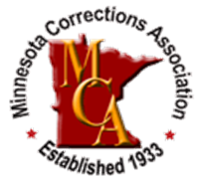
MCA SPRING WORKSHOP
“I Need a Mental Health Day”
MARCH 21, 2019
St. Peter Community Center: 601 S. Washington Ave, St. Peter MN 56082

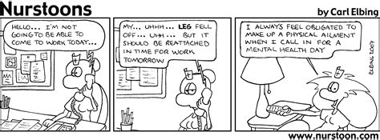
Please join us for an evidence informed workshop for corrections employees that promotes resiliency in your work, health, and home life. Hear from fellow correctional workers as well as mental health professionals regarding their experiences and strategies to reduce stress and improve your well-being; also, they will share resources that are available. We will end the day hearing from motivational speaker, Gaye Hanson, whose motto is “Igniting the Winner within You!”

Training Agenda:
8:30-9 AM: Registration and Resource Fair
9:00-9:15 AM: Introduction with Connie Hartwig, MCA President
9:15-10:15 AM: Lea Atkinson, Atkinson Counseling Services
10:15-10:30 AM: Break/Resource Fair
10:30-11:00 AM: Al Hanson, Critical Incident Stress Management (CISM)
11:00 AM-12:00 PM: Marilyn Dornfeld, NAMI Minnesota
12:00-12:45 PM: Lunch and Resource Fair
12:45-1:45 PM: Mary Mauseth, Olmsted County Sheriff’s Office on True Grit: Building Resilience in Corrections Professionals
1:45-2:45 PM: Amy Hertzog and Neal Huemoeller, Corrections Fatigue to a Critical Incident
2:45-3:00 PM: Break/Resource Fair
3:00-4:00 PM: Gaye Hanson with Great Motivations

Attendee Registration Rates - Early registration rates if payment received by March 9, 2019:
$50 MCA Members
$25 MCA Student/Retiree Members
$85 non-member (includes MCA Membership)
$100 non-member (includes NEW Joint MCA/MACPO Membership)
$95 non-member

*Rates for registration after March 9th or invoices not paid will increase by $25.

You will receive a verification of registration via e-mail with the invoice. If employer is paying for your attendance, you must give the invoice to them for payment; a separate invoice will not be sent to.

Attendee Registration – Click here

Exhibitor & Sponsor Opportunities – Click here
$250 – Exhibitor Registration Rate (if paid by 3/9)
$325 – if paid after 3/9
$500 – Breakfast and Lunch Sponsor Opportunities (includes complimentary exhibit space)

Hotel Accommodations:
AmericInn
700 N Minnesota Ave
St. Peter, MN 56082
507-931-6554
$85.41 plus taxes - check in at 3; check out at 11
Be sure to ask for the MCA block
Lodging is NOT included in event registration.

Cancellation Policy: E-mail cancellations to the MCA office. The following refund schedule will apply: 100% refund for cancellations by 03/01/19; 50% refund 03/01/19 to 3/8/19; no refunds 3/9/19 or after. In lieu of cancellation, you may send someone else to this event.

