Legislative Update
May 8, 2012
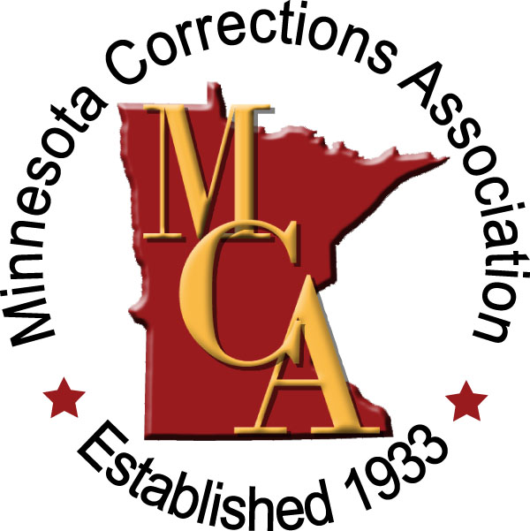

As I prepare this report to you this evening, the State Senate is still debating the Viking Stadium bill and they have been going at in since 2:00 .m. this afternoon. Although the vote will be closer than the House final vote last evening, we do believe there are sufficient votes to pass this legislation. The bills however, from each chamber have a significant number of different clauses which will result in a Conference Committee being named which we believe will start working on compromise language as early as Wednesday morning. The final Conference Committee language then needs to go back for re-passage by both the House and the Senate before it can be sent to the Governor.

As you may already know, both Chambers have passed a bonding bill and that too, differs and requires a Conference Committee to reach consensus before it can be acted upon by the Governor. It is expected that they will also pass another Omnibus Tax bill prior to adjourning in the next few days, since Governor Dayton vetoed the tax bill sent to him over the week-end. These three items have been the major focus of the Legislature these past two weeks. There has been passing of some bills but these items have remained the primary focus. The Legislature has already exceeded their self imposed adjournment date of April 30th. Last year the Republican majority finalized the budget and did not budget for legislative activities beyond the April 30th date so the Legislature is going into deficit spending by about $ 66,000 for every day they meet in May so obviously adjournment is the primary focus now.

As I mentioned in my last few reports to you and in my monthly activity report a few days ago, this has been a most unusual Session and is now often being referred to as " a do-nothing legislature" - lots of political posturing but no significant results, so I think many legislators are hoping the passing of these final three bills will be enough to lead them into the election season. Many others are saying that the result of their activities or lack thereof will be all the political fodder they'll need to obtain a major change in the Legislature in this Fall's election.

I would like to provide you with a brief summary, at least at this point of what did get passed this Session. As of May 4th, 167 bills have been approved by the Legislature and sent to the Governor, and of those Governor Dayton has vetoed 26 of those bills according to my count. We have previously indicated that this was not a significant year for Public Safety/Corrections legislation and in fact, the House even refused to prepare a Public Safety/Corrections Omnibus bill which is most unusual. There was an abbreviated DOC Omnibus bill of only a few pages which was passed, but nothing of real significance. The following is a list of bills which were acted upon this Session pertaining to our interests. It is not all encompassing but a good overview of what we saw happen this Session.

HF 2394 (Chapter 123) Sex offender community notification upon release requirement - signed 2/23/12

SF 2297 (Chapter 153) Jacob's law; law enforcement social services agency notification of child abuse requirement - signed 4/4/12

SF 2084 (Chapter 155) Omnibus Corrections Policy Bill - signed 4/4/12

HF 1829 (Chapter 171) County attorneys and assistant county attorneys firearm carry authorization - signed 4/9/12

SF 1586 (Chapter 175) Creates a felony crime for the neglect or abuse of vulnerable adults - signed 4/18/12

SF 1123 (Chapter 200) Expands list of offenses that constitute "gang activity" to include possession of a firearm by a minor - signed 4/20/12

HF 2160 (Chapter 211) Public Safety bill permitting law enforcement officers to take fingerprints from offenders if needed to resolve a file - signed 4/23/12

HF 738 (Chapter 218) modifies harassment restraining order provisions and also requires DOC to post a web site 30 days notice before a hearing where the Commissioner is considering release of offender who committed the murder of a peace officer or corrections officer – signed 4/24/12

HF 469 (Chapter 223) Makes changes to the harassment restraining order, allowing applications for restraining orders may be filed in county of residence or county where harassment took place - signed 4/24/12

SF 2464 (Chaper 229) Corrects error in calculation of presumptive sentences on the Sex Offender Grid – signed 4/23/12

HF 2149 (Chapter 227) Expands definition of qualified domestic violence related offenses to include female genital mutilation against a family member - signed 4/23/12

HF 2508 (Chapter 240) modifies the definition of synthetic cannabinoids and enhances the penalties for selling such – signed 4/27/12

HF 2294 (Chapter 247) This is the Health and Human Services Omnibus Budget Bill; this has numerous important provisions and is worthy of review – signed 4/28/12

This is a summary of enacted legislation. We will continue to research the impact of all new legislation as it affects our delivery system and continue discussions with our organizational partners of items of mutual concern. Feel free to contact me with any questions or concerns. Now we'll begin preparing for a Legislative Update Workshop at the Fall Institute and begin our work to plan and establish our priorities for the next year.

Submitted by:
Calvin Saari
sisuwithsaari@aol.com

